Appendix 2
Equality Impact Assessment (EqIA) October 2022

You will need to produce an Equality Impact Assessment (EqIA) if:

- You are developing a new policy, strategy, or service
- You are making changes that will affect front-line services
- You are reducing budgets, which may affect front-line services
- You are changing the way services are funded and this may impact the quality of the service and who can access it
- You are making a decision that could have a different impact on different groups of people
- You are making staff redundant or changing their roles

Guidance notes on how to complete an EqIA and sign off process are available on the Hub under Equality and Diversity.
You must read the guidance notes and ensure you have followed all stages of the EqIA approval process (outlined in appendix 1).
Section 2 of the template requires you to undertake an assessment of the impact of your proposals on groups with protected characteristics. Equalities and borough profile data, as well as other sources of statistical information can be found on the Harrow hub, within the section entitled: Equality Impact Assessment - sources of statistical information.

Equality Impact Assessment (EqIA)

Type of Decision:
Title of Proposal | Household Support Fund 3 | Date EqIA created: September 2022
Name and job title of completing/lead Officer | Alex Dewsnap, Director of Strategy and Partnerships

Directorate/ Service responsible
Organisational approval
EqIA approved by Head of EDI | Name: Shumailla Dar | Signature  ☒  Tick this box to indicate that you have approved this EqIA  Date of approval:

- Summary of proposal, impact on groups with protected characteristics and mitigating actions
(to be completed after you have completed sections 2 - 5)
- What is your proposal?
Harrow Council’s Household Support Fund grant allocation for the period October 2022 – March 2023 is £1,476,707.18, which must be spent by 31 March 2023. The funding includes:
- The purchase of select codes for 1600-1800 households on housing benefit. The codes will be to the value of £100 and will be valid for 3 months and are redeemable in supermarkets chains and major retailers and will be distributed via post by Blackhawk.
- Approve the purchase of Free school meals (FSM) vouchers for approximately 6500 vulnerable households with children.
- An allocation of £7000 to the Self Neglect and Hoarding team to support up to 100 extremely vulnerable households with mental health conditions, elderly and frail and 27 households with No Recourse to Public Funds, as vouchers are not suitable.
- An application-based scheme to be administered by the Revenues & Benefits team.

- Summarise the impact of your proposal on groups with protected characteristics

Based on the data available we do not anticipate that the delivery of the extension Household Support Fund will have a negative impact on Harrow residents or result in any direct or indirect discrimination of any group that shares protected characteristics. If anything, we would expect that there would be a positive impact as the key driver is around reducing hardship and the evidence in Harrow is that some groups are more disadvantaged from an income inequality perspective than others, and would as a result of the Council’s proposed allocation be positively impacted.
c) Summarise any potential negative impact(s) identified and mitigating actions

- While the EQIA process has not identified any negative impacts on groups with protected characteristics, the following issues should be taken into consideration:
- Population and borough profile data for Harrow referenced in this EQIA is based on 2011 Census data, which is out of date. Therefore, the population profile of the borough may have changed significantly since then. This makes it difficult to identify disproportionality and inequality faced by certain groups in Harrow. Although we will monitor the implementation of the scheme on a monthly basis, the fact that it is to be completed by the end of September 2022 makes further and more substantial changes more difficult.
- It is also recommended that equality monitoring is robust and incorporated as part of the performance monitoring process for the scheme to enable any changes to be made before September 2022.

2. Assessing impact
You are required to undertake a detailed analysis of the impact of your proposals on groups with protected characteristics. You should refer to borough profile data, equalities data, service user information, consultation responses and any other relevant data/evidence to help you assess and explain what impact (if any) your proposal(s) will have on each group. Where there are gaps in data, you should state this in the boxes below and what action (if any), you will take to address this in the future. |  | What does the evidence tell you about the impact your proposal may have on groups with protected characteristics? Click the relevant box to indicate whether your proposal will have a positive impact, negative (minor, major), or no impact
Protected characteristic | For each protected characteristic, explain in detail what the evidence is suggesting and the impact of your proposal (if any). Click the appropriate box on the right to indicate the outcome of your analysis. | Positive impact | Negative  impact |  | No impact
 |  |  | Minor | Major
Age | Harrow has a resident population of 251,160. It has an above average working age population aged 16-64 of just under 63% (158,000) and a growing younger population aged 0-15, which is higher than the London average, suggesting that the borough is a popular destination for families.  - As with most areas in the country, the borough has an ageing population. it is expected that the number of residents aged 65 plus will increase by 38% and those aged 85 plus could increase by 60% by 2030.  - Data available shows that the pandemic has adversely impacted young people aged 18-24, with 1 in 10 young people out of work.  - Harrow has one of the lowest proportion of young people Not in Education, Employment and Training (NEETS). However, due to the Covid-19 pandemic, there has been a significant increase in numbers, from 0.8% to 1.8%.  It should be noted that the number of pupils eligible for Free School Meals has increased from 3,695 in 2019 to 6263 in May 2022. Therefore the targeting of the Scheme on Free School Meals has a positive impact on those children eligible for Free School Meals.  The targeting of households on Housing benefit will have a positive impact for people of working age and the application based scheme will have a positive impact on working age and those of pensionable age due to the qualifying benefits. Our identified cohort of care leavers moving to permanent accommodation will have a positive impact on the 16-24 age category.  We also know from data from the Community Hub, that they are supporting all age groups but disproportionately more in the younger age groups than the pensioner age groups compared to our borough population. A third of those coming to the hub for food support are families with children  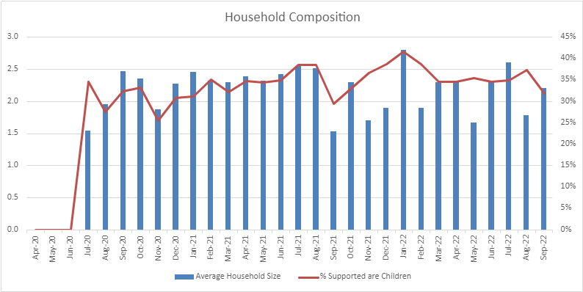  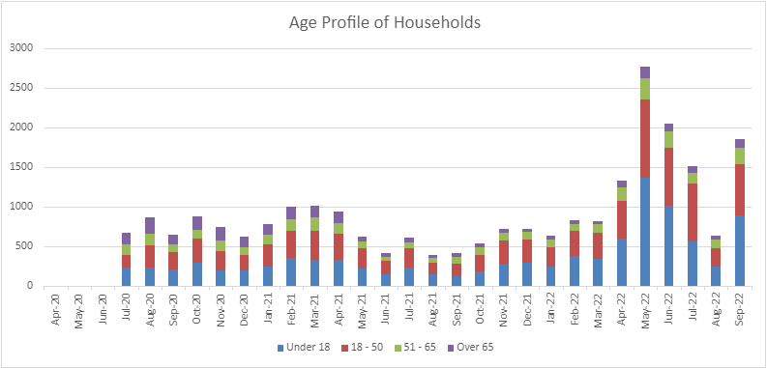  For those households with rent arrears due to the pandemic, the Councils Housing Benefit data shows the breakdown against age as follows:  Council tenants Temporary accommodation tenants Total  21 – 24 5 (2%) 1 (1%) 6 (2%)  25 – 34 16 (8%) 8 (10%) 24 (8%)  35 – 44 47 (23%) 26 (34%) 73 (26%)  45 – 54 59 (29%) 22 (29%) 81 (29%)  55 – 64 49 (24%) 7 (9%) 56 (20%)  65+ 21 (10%) 1 (1%) 22 (8%)  Data not available 7 (3%) 12 (16%) 19 (7%)  Total 204 77 281  Impact  The Free school meals (FSM) element of the scheme will naturally support those families with children which although the data doesn’t breakdown to assess exactly where parental age will be, it is more than likely that the majority of parents would be in the 30-60 age bracket (given as a proxy for this over 75% of those people on CTS are within this age bracket). The growth in eligibility of Free School Meals from 10-15% from 2019-2021 has a positive impact on age for children. On this basis, taken altogether, the various elements of the scheme would have a positive impact on age. | ☒ | ☐ | ☐ | ☐
Disability | - ONS data for 2016-2018 shows that 19,208, (12.2%) of Harrow’s working age population have a disability.  - There is a strong correlation between disability, in particular the extent of the disability, and economic inactivity and therefore experiencing potential financial hardship.  The Housing Benefits Team do not capture whether or not a Housing Benefit claimant in Emergency Accommodation would classify themselves as having a disability, only what disability benefits they receive. This is also only recorded if the services know that the benefit is received and, in most instances, only if it affects the level of entitlement. For instance, there are 6 claims where at least one member of the household in receipt of a Personal Independent Payment, and in 2 of these a member of the household is also in receipt of Employment Support Allowance.  With regards Free School Meals, across all Harrow schools, the percentage of pupils with an Education and Healthcare Plan who are eligible for FSM increased from 19.6% (223 pupils) in 2019 to 26.9% (345 pupils) in 2021. In parallel, the percentage of pupils on SEN Support Plan who are eligible for FSM increased from 17.2% (633 pupils) in 2019 to 24.1% (867 pupils) in 2021. Pupils with No SEN who are eligible for FSM increased too, from 8.8% (2,839 pupils) in 2019 to 13.6% (4,516 pupils) in 2021.  Number and percentage of Pupils eligible for Free School Meals in Harrow Primary, Secondary, Special, Nursery and PRU schools by SEN Provision (Enrolments: Current and Dual-Main)  SEN Provision 2019 2020 2021  Number of pupils eligible for FSM Percentage of pupils eligible for FSM All pupils Number of pupils eligible for FSM Percentage of pupils eligible for FSM All pupils Number of pupils eligible for FSM Percentage of pupils eligible for FSM All pupils  Education and Health Care Plan (EHCP) 223 19.6% 1136 266 22.1% 1202 345 26.9% 1281  SEN Support 633 17.2% 3685 718 19.8% 3627 867 24.1% 3593  No SEN 2839 8.8% 32440 3347 10.1% 33096 4516 13.6% 33312  Total 3695 9.9% 37261 4331 11.4% 37925 5728 15.0% 38186  Source: Spring School Census 2019, 2020 and 2021  Disability benefits are listed as qualifying benefits for the application based scheme. The Targeting of households known to the Self-Harm and Hoarding team will also support vulnerable adults with mental health conditions. Disability is also a increasing reason for people requesting food support from the community hub.  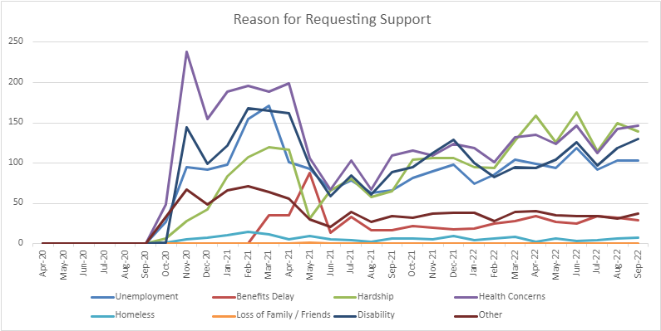  Impact  The Council does not collect data on disability. However, the inclusion of disability related benefits as qualifying benefits for the application based scheme and support for the community hub, means we will be able to report as part of the monitoring information how many households with a disability, which would include non-physical disabilities such as mental health have been supported. However, from the data the Council has on children eligible for Free School Meals, it can be concluded that these aspects of the scheme would have a positive impact on those people and families who are disabled and in receipt of disability benefits or FSM. | ☒ | ☐ | ☐ | ☐
Gender  reassignment | - There is limited national data collected for this characteristic. We will need to consider the inequalities and discrimination experienced for this protected group when data becomes available.  - The charity GIRES estimated in their Home Office funded study in 2009 the number of transgender people in the UK to be between 300,000 and 500,000. More recently Stonewall advised that it is estimated that around 1% of the population might identify as trans, including people who identify as non-binary. This would represent about 600,000 trans and non-binary people in Britain and about 2,500 people in Harrow.  Impact  At this stage there is no way of concluding whether the Household Support Fund 2 would have either a positive or negative impact on this group. | ☐ | ☐ | ☐ | ☒
Marriage and Civil Partnership | - At the time of the 2011 Census 54% of Harrow’s residents were married, which was the highest level in London. 21% of households were married, or in same-sex civil partnerships, with dependent children, the highest level in London. At October 2020 there have been 144 Same Gender Civil Partnerships in Harrow, 25 of which has been converted to a Marriage. There have been 8 Opposite Gender Civil Partnerships. There have been 57 Same Sex marriages.  Impact  The extension Household Support Fund implementation will aim to support residents regardless of their partnership status. | ☐ | ☐ | ☐ | ☒
Pregnancy and Maternity | - ONS births figures show Harrow as having 3,526 live births in 2019. 14 live births per 1000 population is higher than the England & Wales average of 10.8  - The borough has the worst infant mortality rate in London, at a rate of 5.1 deaths per 1000 live births, which is a strong indicator of poverty and inequality in the borough.  Impact  Although there isn’t any data the Council holds for CTS or Free School Meals on whether recipients (or their parents) are either pregnant or on maternity leave the extension Household Support Fund implementation will aim to support residents regardless of their status. | ☐ | ☐ | ☐ | ☒
Race/  Ethnicity | 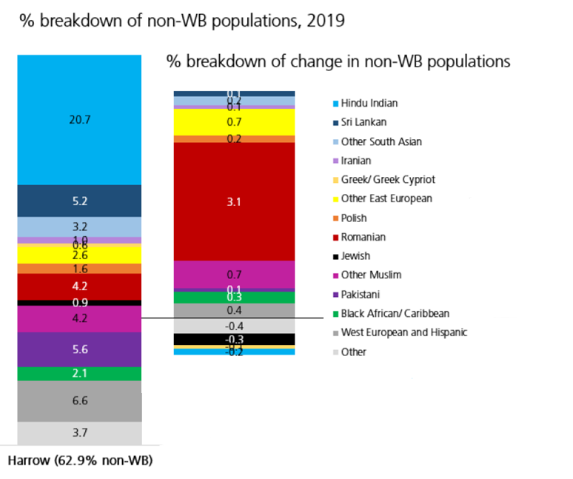  - Harrow is one of the most culturally diverse local authorities in the UK, with over 60% of residents from Black, Asian, and Multi-Ethnic backgrounds and an estimated 20% Eastern European community, which is fast growing. Black African (notably the Somali Community) groups have been fast growing over the last 6 years or so, as has the Afghan community.  - Unemployment rates are significantly higher in certain areas of the borough, particularly in the Wealdstone and Marlborough wards (central Harrow) and  Roxbourne (south Harrow), focused in an around the Rayners Lane estate and among residents classified as Black and Other ethnic groups. These areas are also ranked high on the indices of deprivation for the UK.  - The majority of 16–18-year-olds that are classed as NEET are from Black, Asian and Minority Ethnic backgrounds and located in wards with high levels of deprivation. However, the data also shows that the single largest ethnic group of pupils aged 16-18 classed as NEET is White British.  - At ward level Marlborough and Wealdstone have the highest number of households in need of re-housing. These respectively have a Black, Asian and Minority Ethnic population of 77% and 75%.  - The highest rates of overcrowding is in Greenhill ward (97.5 per 1,000 households) and a Black, Asian and Minority Ethnic population of 74% (2011 census).  - Data shows us that some Black, Asian and Minority Ethnic residents are more likely to experience barriers to employment due to lack of English language, functional and digital skills and therefore more likely to be in receipt of financial support through such things as Universal Credit, Council Tax support and (if there are children in the household) Free School Meals.  With regards Free School Meals, in 2021, the highest proportion of pupils who are eligible for FSM are of Traveller of Irish Heritage Background (89.6% - 60 pupils). This percentage has increase from 2019 (67.6% - 46 pupils), however the population numbers of this ethnic group are significantly low. The second highest group are of White and Black Caribbean ethnic origin (34.6% - 187 pupils), having increased from 24% (131 pupils) in 2019. The third highest group are of Black Caribbean ethnic origin (32.8% - 314 pupils). This percentage has increased from 23.4% (235 pupils) in 2019. The table below gives the full breakdown of pupils on FSM compared to the overall pupil population in Harrow for 2019-2021.  Number and percentage of Pupils eligible for Free School Meals in Harrow Primary, Secondary, Special, Nursery and PRU schools by Ethnicity (Enrolments: Current and Dual-Main)  Ethnicity 2019 2020 2021  Number of pupils eligible for FSM Percentage of pupils eligible for FSM All pupils Number of pupils eligible for FSM Percentage of pupils eligible for FSM All pupils Number of pupils eligible for FSM Percentage of pupils eligible for FSM All pupils  Traveller of Irish Heritage 46 67.6% 68 65 73.9% 88 60 89.6% 67  White and Black Caribbean 131 24.0% 546 156 28.2% 553 187 34.6% 541  Black Caribbean 235 23.4% 1003 267 27.0% 990 314 32.8% 957  Black – African 483 21.0% 2305 526 23.2% 2272 638 29.7% 2148  Any Other Ethnic Group 348 18.7% 1857 442 22.5% 1966 592 29.7% 1994  White and Black African 68 21.3% 319 80 23.3% 343 99 28.2% 351  Any Other Black Background 80 20.0% 400 92 22.8% 403 110 27.5% 400  Gypsy / Roma 6 17.6% 34 8 16.3% 49 11 26.2% 42  Refused 44 11.9% 369 69 16.5% 418 102 21.0% 485  Any Other Mixed Background 203 15.6% 1303 231 18.0% 1280 266 20.0% 1327  Bangladeshi 38 12.4% 307 46 14.5% 318 61 18.8% 325  Any Other Asian Background 756 10.7% 7077 911 12.8% 7135 1297 18.3% 7093  White – British 448 12.4% 3623 481 13.9% 3460 565 17.1% 3296  Information Not Yet Obtained 12 12.9% 93 16 15.4% 104 20 16.4% 122  Pakistani 225 11.8% 1902 228 12.3% 1861 289 15.7% 1844  White and Asian 88 9.2% 953 122 12.1% 1007 152 14.5% 1046  White – Irish 27 7.7% 350 25 8.0% 311 27 9.6% 280  Any Other White Background 255 4.2% 6105 326 5.2% 6250 594 9.4% 6340  Chinese 6 3.3% 180 10 5.1% 197 12 5.9% 203  Indian 196 2.3% 8467 230 2.6% 8920 332 3.6% 9325  Total 3695 9.9% 37261 4331 11.4% 37925 5728 15.0% 38186  Source: Spring School Census 2019, 2020 and 2021  For those households with rent arrears due to the pandemic, the Councils Housing Benefit data shows the breakdown against ethnicity as follows:  Council tenants Temporary accommodation tenants Total  Asian / Asian British 25 (12%) 13 (17%) 38 (14%)  Black / African / Caribbean / Black British 66 (32%) 16 (20%) 82 (29%)  Mixed / multiple ethnic groups 13 (6%) 2 (3%) 15 (5%)  White 50 (25%) 13 (17%) 63 (22%)  Other ethnic group 5 (2%) 2 (3%) 7 (3%)  Prefer not to say 45 (22%) 31 (40%) 76 (27%)  Total 204 77 281  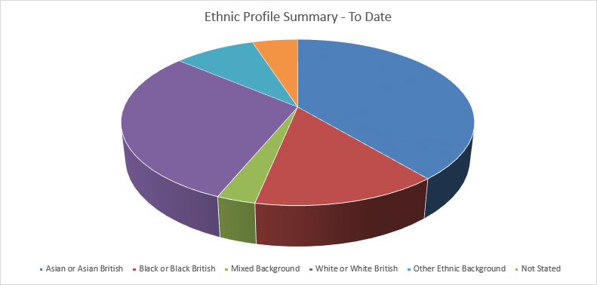  For those residents accessing food support from the Community Hub, the largest share are from an Asian or Asian British background. The number accessing support who are black or Black British looks disproportionately higher than the general Harrow Population.  Impact  Although there isn’t any data the Council holds for housing benefit on the ethnicity of recipients (or their parents), the proxy indicator of Black, Asian and Minority Ethnic residents being more likely to experience barriers to work (last bullet above), would suggest that all the elements of the Household Support Scheme will have a positive impact on those with a Black, Asian and Minority Ethnic heritage, by virtue of the relationship between barriers to employment, hardship and a higher likelihood of therefore being in receipt of financial assistance. Black heritage, Bangladeshi and Pakistani pupils are also disproportionately represented on the cohort of children in receipt of Free School Meals and users of the Community Hub when compared to the broader population, so again the targeting of the Scheme will have a positive impact on race/ethnicity. Similarly, looking at rent arrears data black heritage households are also disproportionately represented in this cohort, so would benefit from the scheme. | ☒ | ☐ | ☐ | ☐
Religion or belief | - Religious diversity is strong in Harrow. At the 2011 Census Harrow was the most religiously diverse borough in the country. Harrow had the highest number (and proportion) of Hindu followers in the country (25.3%), the highest number of Jains (2.2%) and the second highest number of Zoroastrians. Harrow 's Jewish community was the sixth largest nationally. 37.3% of residents were Christians (the 5th lowest proportion in the country) and 12.5% were Muslims. Harrow had the 2nd lowest ranking for ‘no religion’.  - As the population’s ethnic composition changes, rates of participation in various religions are also likely to change.  - There is limited data on employment/unemployment rates for Harrow by religion.  - Data for London suggests that educational attainment and employment among the capital’s Muslim community is lower than those from other faith groups located in the borough.  Impact  The Scheme will aim to support all residents regardless of their religion or belief, and where possible monitoring information will be gained to understand the impact on this characteristic. | ☐ | ☐ | ☐ | ☒
Sex | - The Government’s population estimates as of mid-2019 show that the total population of Harrow is now 251,200, made up of 125,800 men and 125,400 women. Overall, the number of males and females living in Harrow is very similar.  - Economic activity among Harrow’s male population is higher than the London average at 86%, compared with 83%. However, economic activity among females in the borough is lower than the London average at 72%.  - Harrow is a low wage borough, with both men and women that are employed in the borough earning less than the London average of £760earning less compared to men. Women earn less than men in the borough. Average gross weekly earnings among women working in Harrow is £500, nearly 38% lower than the London average of £688.  - While the pandemic may have negatively impacted both sexes, the shift to home working may have had a positive impact in enabling women to return to work, as they are able to share childcare responsibilities.  With regards Free School Meals, across all Harrow schools, the percentage of Female pupils who are eligible for FSM increased from 10% (1,858 pupils) in 2019 to 14.8% (2,836 pupils) in 2021. In parallel, the percentage of Male pupils who are eligible for FSM increased from 9.8% (1,837 pupils) in 2019 to 15.2% (2,892 pupils) in 2021. In 2021, the proportion of male pupils who are eligible for FSM is marginally higher than the proportion of female pupils. This is in contrast to the previous years (2019 and 2020) where the proportion of female pupils eligible for FSM was higher than the proportion of male pupils. However, the difference does not suggest there is any disproportionate impact with regards gender for pupils in receipt of Free School Meals.  For those households with rent arrears due to the pandemic, the Councils Housing Benefit data shows the breakdown against female and male headed households as follows:  Council tenants Temporary accommodation tenants Total  Female headed household 136 (67%) 55 (71%) 191 (68%)  Male headed household 61 (30%) 19 (25%) 80 (28%)  Data not available 7 (3%) 3 (4%) 10 (4%)  Total 204 77 281  Impact  On the basis that economic activity is lower in women than in men, earnings are less in women than men and more households in council housing or temporary accommodation are headed by women there is a higher likelihood that the scheme will have a more positive impact on women than men. However the Household Support Scheme is targeted at all age groups in greatest financial hardship, which is a positive impact. | ☒ | ☐ | ☐ | ☐
Sexual Orientation | - The Office for National Statistics estimated in 2014, 2.6% of Londoners identify as lesbian, gay, or bisexual, the highest of any UK region. There is no official data on sexual orientation for Harrow in relation to employment.  - LGBT people are also likely to be underrepresented among business owners within Harrow.  Impact  Although there isn’t any data the Council holds for housing benefit or Free School Meals on the sexual orientation of recipients (or their parents) the fact that there is a higher likelihood that families with children will be heterosexual couples, the Household Support Fund 2 is more likely to have a positive impact on those whose sexual orientation is heterosexual. However, the implementation of the scheme will aim to support residents regardless of their sexual orientation. | ☒ | ☐ | ☐ | ☐
2.1 Cumulative impact – considering what else is happening within the Council and Harrow as a whole, could your proposals have a cumulative impact on groups with protected characteristics?
☒ Yes No ☐

If you clicked the Yes box, which groups with protected characteristics could be affected and what is the potential impact? Include details in the space below
- There will be a positive impact on working households with children.
- There will be a positive impact on residents in receipt of housing benefit.
- There will be a positive impact on vulnerable households.
- There will be a positive impact on Harrow residents who can take advantage of the ongoing food resource via the Community Hub.

2.2 Any other impact - considering what else is happening nationally/locally (national/local/regional policies, socio-economic factors etc.), could your proposals have an impact on individuals/service users, or other groups?
☒ Yes No ☐
If you clicked the Yes box, Include details in the space below
- The Household Support Fund 3 is principally to support those families in hardship, so all groups who receive funding will be from a group impacted by hardship.
- It should be noted that the number of pupils eligible for Free School Meals has increased from 3,695 in 2019 to 6263 in 2022 (which in percentage terms is a move from 10% of the pupil population in Harrow in 2019 to 15% in 2021).

3. Actions to mitigate/remove negative impact
Only complete this section if your assessment (in section 2) suggests that your proposals may have a negative impact on groups with protected characteristics. If you have not identified any negative impacts, please complete sections 4 and 5.

In the table below, please state what these potential negative impact (s) are, mitigating actions and steps taken to ensure that these measures will address and remove any negative impacts identified and by when. Please also state how you will monitor the impact of your proposal once implemented.
State what the negative impact(s) are for each group, identified in section 2. In addition, you should also consider, and state potential risks associated with your proposal. | Measures to mitigate negative impact (provide details, including details of and additional consultation undertaken/to be carried out in the future). If you are unable to identify measures to mitigate impact, please state so and provide a brief explanation. | What action (s) will you take to assess whether these measures have addressed and removed any negative impacts identified in your analysis? Please provide details. If you have previously stated that you are unable to identify measures to mitigate impact please state below. | Deadline date | Lead Officer
Limited data is available on the demographic and ethnic profile of those who will be beneficiaries of the various elements of the scheme | - Monitoring data will be developed as the scheme is rolled out and reported on a monthly basis | - The Monthly data will be reported to the project working group and if necessary further demographic data will be sought to support the overall understanding of the impact of the scheme. | Mar 2023 | Angelica Stoichkov

4. Public Sector Equality Duty
How does your proposal meet the Public Sector Equality Duty (PSED) to:
- Eliminate unlawful discrimination, harassment and victimisation and other conduct prohibited by the Equality Act 2010
- Advance equality of opportunity between people from different groups
3. Foster good relations between people from different groups

Include details in the space below

- The Scheme will help to advance the equality of opportunity for groups who share relevant protected characteristics and those who do not by addressing inequalities around access to financial support for many groups in financial hardship.
- The Scheme will help foster good relations between communities through the creation of financial support for those most in need.

5. Outcome of the Equality Impact Assessment (EqIA) click the box that applies
☐ Outcome 1
No change required: the EqIA has not identified any potential for unlawful conduct or disproportionate impact and all opportunities to advance equality of opportunity are being addressed

☒ Outcome 2
Adjustments to remove/mitigate negative impacts identified by the assessment, or to better advance equality, as stated in section 3&4

☐ Outcome 3
This EqIA has identified discrimination and/ or missed opportunities to advance equality and/or foster good relations. However, it is still reasonable to continue with the activity. Outline the reasons for this and the information used to reach this decision in the space below.

Include details here
See mitigations section as this refers to those on pensionable age.

Nomis 2019
ONS -2018 mid-year estimates
Poppi and Pansi projections to 2030
DWP Job claimant data April 2021
NEETS data at December 2020.
Harrow Economic assessment 2019-2020:population
Harrow Economic Assessment: 2019-2020:population
Annual Population Survey 2018.
NOMIS: Labour supply ( at December 2020)
NOMIS: earnings by place of work 2020
NOMIS: earnings by place of work: 2020
Trust for London: London’s Poverty profile 2016.

